

SUMMER FISH FRIDAY LUNCH – Friday 28 June 2024

under the auspices of the late

BRIAN IVERSON and in support of

CANCER RESEARCH UK

The Spring Fish Friday in memory of Brian Iverson and in aid of Cancer Research UK was a great success. In response to the requests of many of those present, the Club has decided to make these Fish Fridays a regular event in the Club’s calendar, the Summer Fish Friday to be held on 28 June.

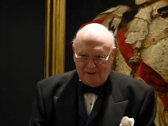

Brian Iverson is remembered with fondness for the many convivial lunches that he arranged at the CUC and for the glittering events he organised as Chairman of the Mayfair Branch of Cancer Research UK.

All members and their guests are invited to share in the conviviality of this Summer Fish Friday.

Members are invited to make donations to the Mayfair Branch of Cancer Research UK at this link: <https://fundraise.cancerresearchuk.org/page/mayfair-branch-of-cancer-research-uk>

Please note that this link is for donations only, and that payment for the lunch should be made to the Club in the usual way.

Reception 12.15 and Lunch 12.45

Menu

Cream of Field Mushrooms, Smoked Paprika Cheese Straw

\*\*\*

Poached Haddock Fillet, Wilted Spinach, Parsley Steamed Potatoes, Buttered Garden Peas and Carrots, Chive-Pernod Fish Veloute

\*\*\*

Bakewell Tart with Vanilla Custard

£49