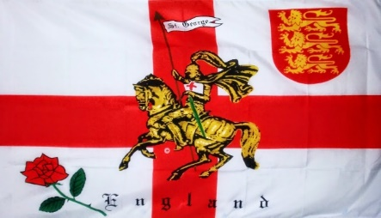

Tuesday 23rd April 2024
St George’s Day Lunch
Dining Room Service

Beef to be carved in Dining Room

Menu

Cream of Watercress Soup with Crispy Ham
***
Braised Short Rib of English Beef, Horseradish Creamed Potatoes, Seasonal Vegetables, Red Wine Gravy
***
Sticky Toffee Pudding, Caramel Sauce and Ice Cream

£36.50

