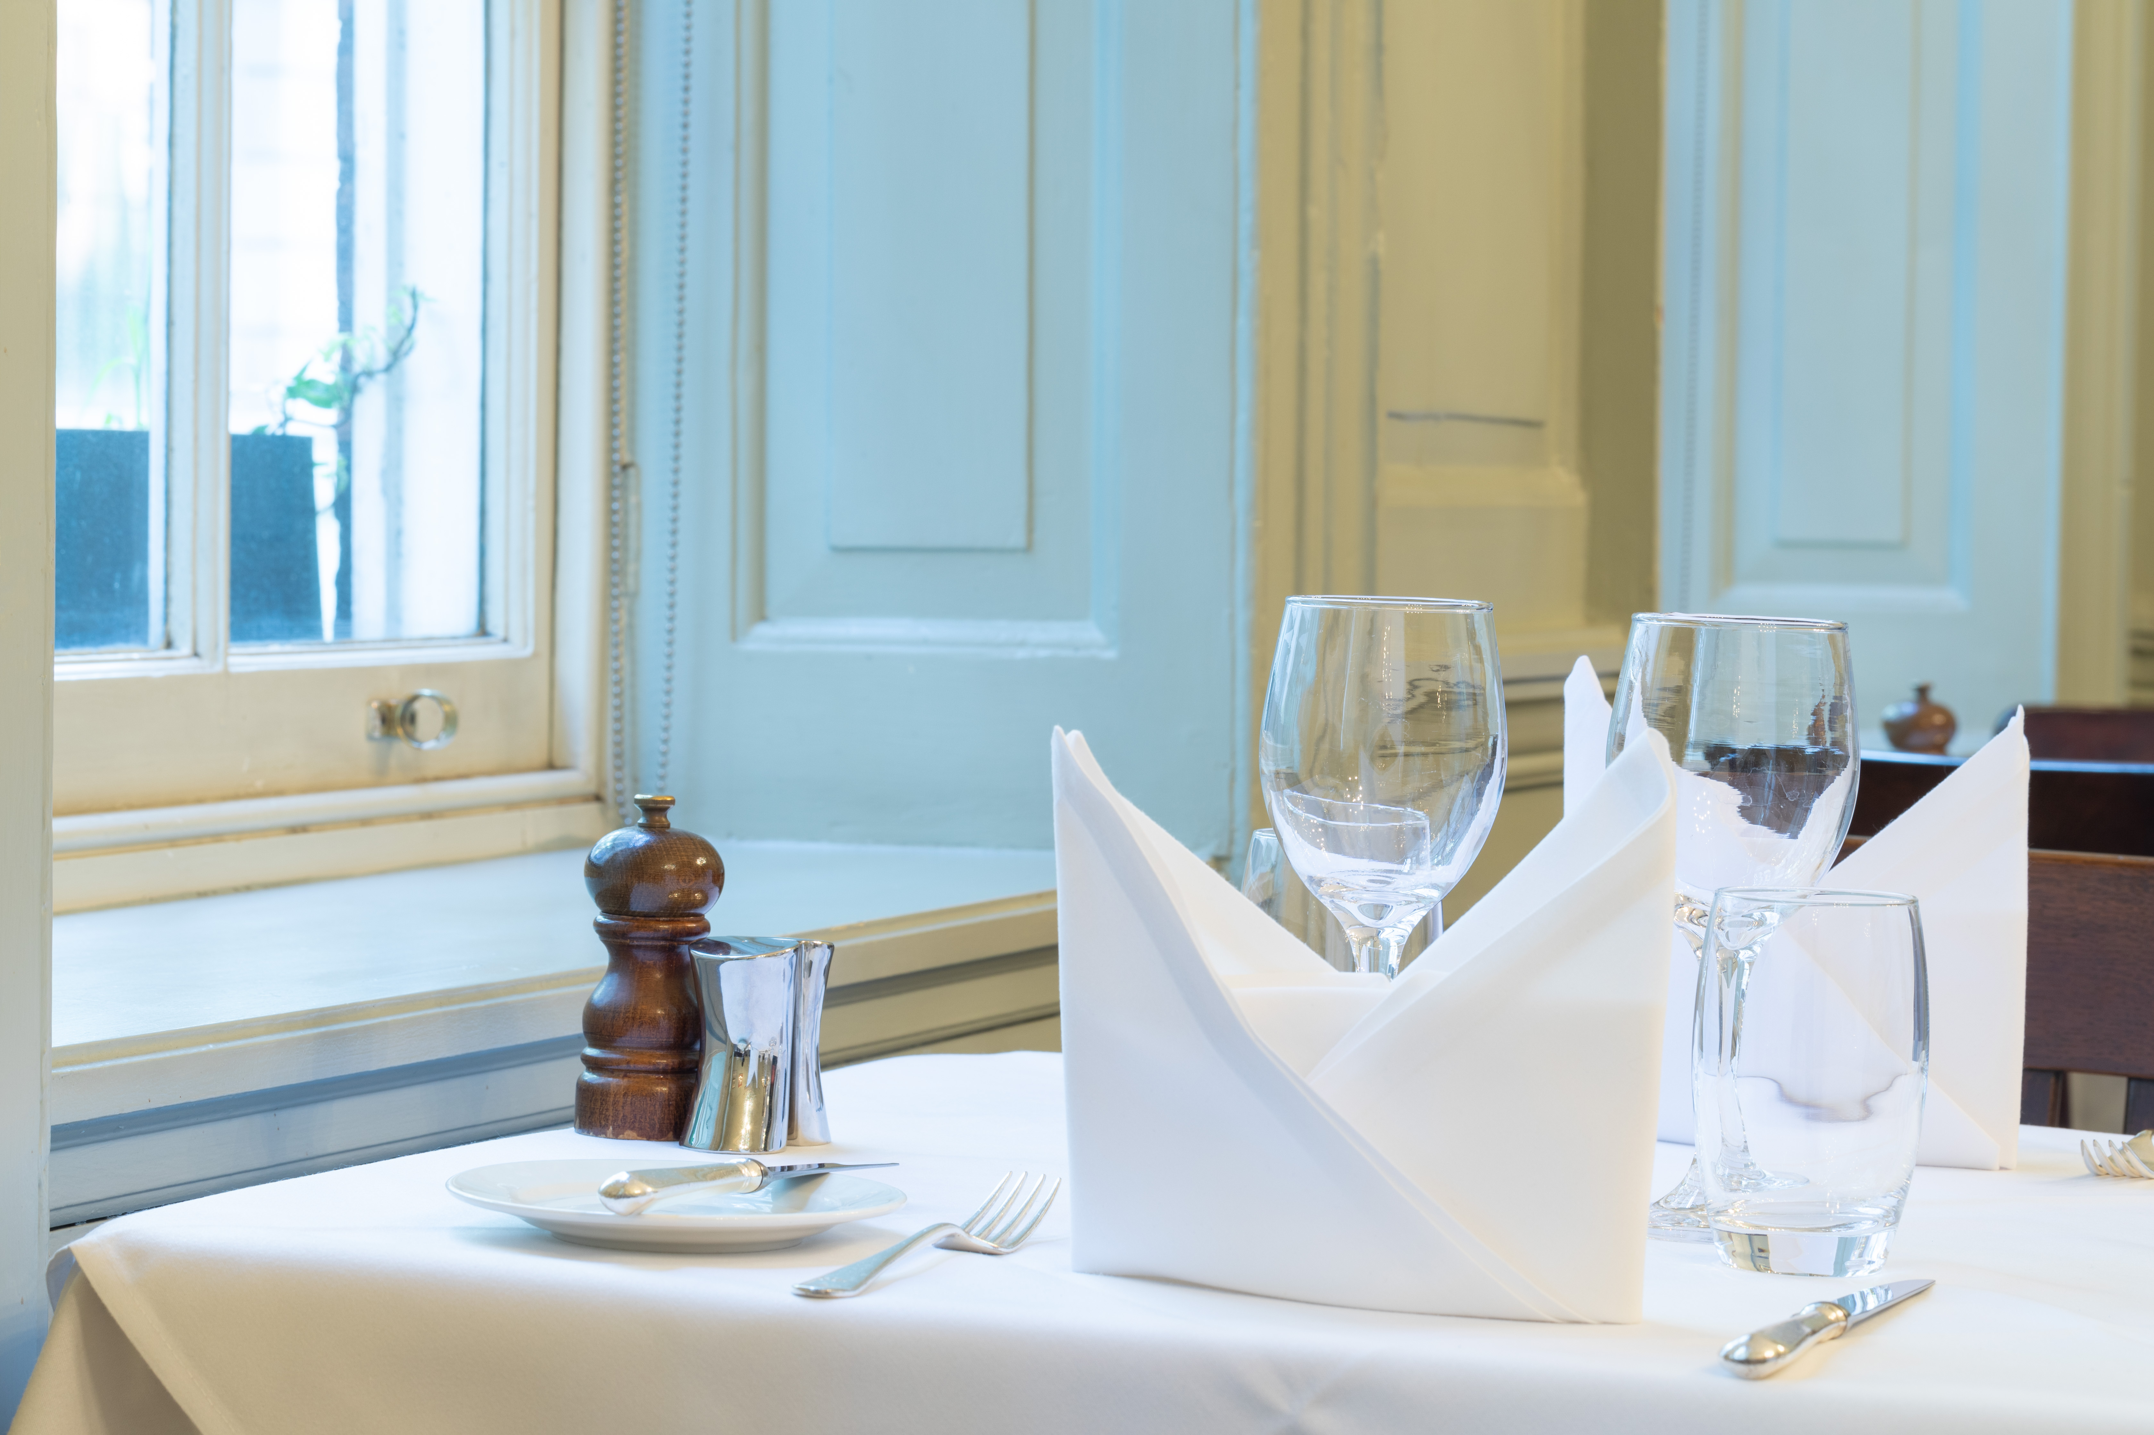

Younger Members Dinner
6.30 for 7pm

Thursday 25 April 2024

Main

Homemade Chicken and Chorizo Tortellinis served with Wilted Spinach, Sautéed Mushrooms and Pancetta, Garden Peas, and Basil Cream

Dessert

Warm Apple and Cinnamon Cake, Vanilla Custard

Half Bottle Wine

£40

